Project 01 - 1 Hour

Deploying a Scalable Web Application with Persistent Storage and Advanced Automation

Objective:
Deploy a scalable web application using Docker Swarm and Kubernetes, ensuring data persistence using a single shared volume, and automate the process using advanced shell scripting.

Overview:
- Step 1: Set up Docker Swarm and create a service.
- Step 2: Set up Kubernetes using Minikube.
- Step 3: Deploy a web application using Docker Compose.
- Step 4: Use a single shared volume across multiple containers.
- Step 5: Automate the entire process using advanced shell scripting.

Step 1: Set up Docker Swarm and Create a Service

1.1 Initialize Docker Swarm

1.2 Create a Docker Swarm Service

Step 2: Set up Kubernetes Using Minikube

2.1 Start Minikube

2.2 Deploy a Web App on Kubernetes
Create a deployment file named webapp-deployment.yaml:
Apply the deployment:
kubectl apply -f webapp-deployment.yaml
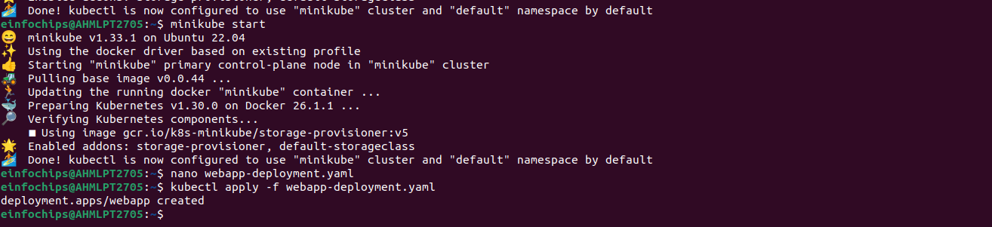

2.3 Expose the Deployment

Step 3: Deploy a Web Application Using Docker Compose

3.2 Deploy the Web Application

Step 4: Use a Single Shared Volume Across Multiple Containers

4.1 Update docker-compose.yml to Use a Shared Volume

4.2 Deploy with Docker Compose

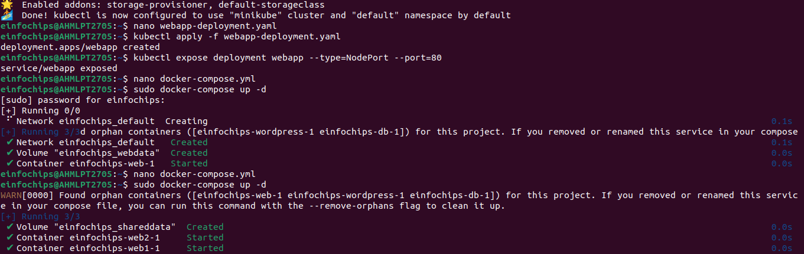

Step 5: Automate the Entire Process Using Advanced Shell Scripting

5.1 Create a Shell Script deploy.sh

5.2 Make the Script Executable

5.3 Run the Script

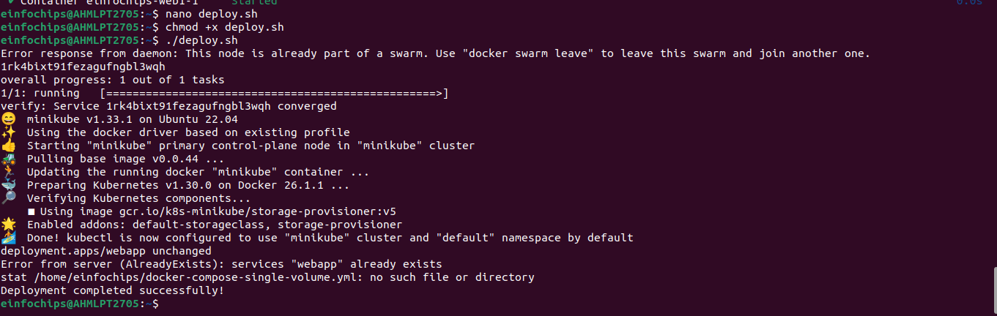

Project 02 - 1 Hour

Comprehensive Deployment of a Multi-Tier Application with CI/CD Pipeline

Objective:
Deploy a multi-tier application (frontend, backend, and database) using Docker Swarm and Kubernetes, ensuring data persistence using a single shared volume across multiple containers, and automating the entire process using advanced shell scripting and CI/CD pipelines.

Overview:
- Step 1: Set up Docker Swarm and create a multi-tier service.
- Step 2: Set up Kubernetes using Minikube.
- Step 3: Deploy a multi-tier application using Docker Compose.
- Step 4: Use a single shared volume across multiple containers.
- Step 5: Automate the deployment process using advanced shell scripting.

Step 1: Set up Docker Swarm and Create a Multi-Tier Service

1.1 Initialize Docker Swarm

1.2 Create a Multi-Tier Docker Swarm Service
Deploy the stack:

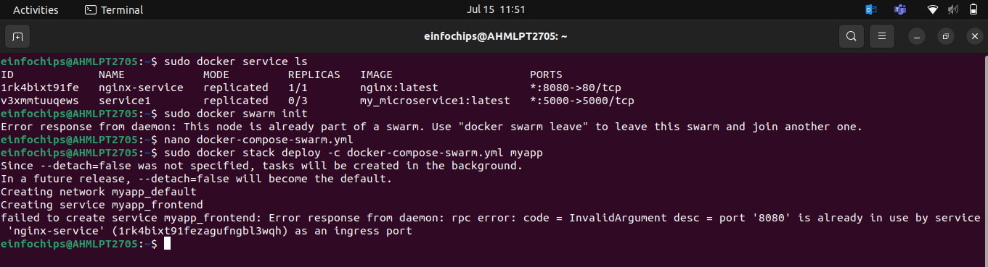

Step 2: Set up Kubernetes Using Minikube

2.1 Start Minikube

2.2 Create Kubernetes Deployment Files
Create db-deployment.yaml:
Create shared-pvc.yaml:
Create db-pvc.yaml
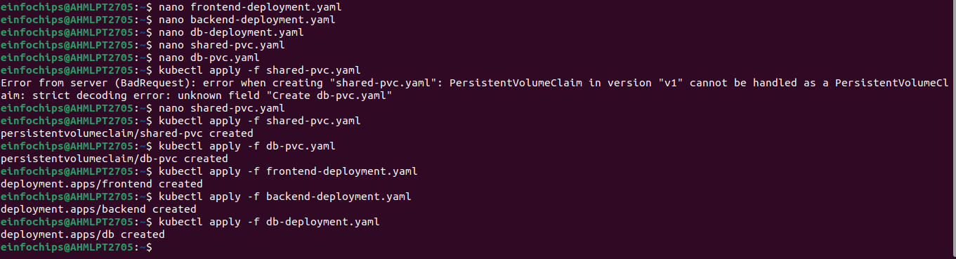
Apply the deployments:

Step 3: Deploy a Multi-Tier Application Using Docker Compose

3.1 Create a docker-compose.yml File

3.2 Deploy the Application

Step 4: Use a Single Shared Volume Across Multiple Containers
